

Widgets

INSTALLATION GUIDE
for Checkout Widget Extension for Magento 1

Step 1 :
Go to your projects root folder & then upload files and folder to the root.

If you have any custom theme then upload theme files to the current theme (app/design/frontend/<Your package>/<Your Theme>).

Step 2 :
Then login to magento admin panel: SYSTEM -> Configuration -> OPENPAY WIDGET -> Widget Setup

1. Enable the module :

Expand 'Openpay Widgets Configuration' & set 'Yes' value against 'Enable Widgets' field.

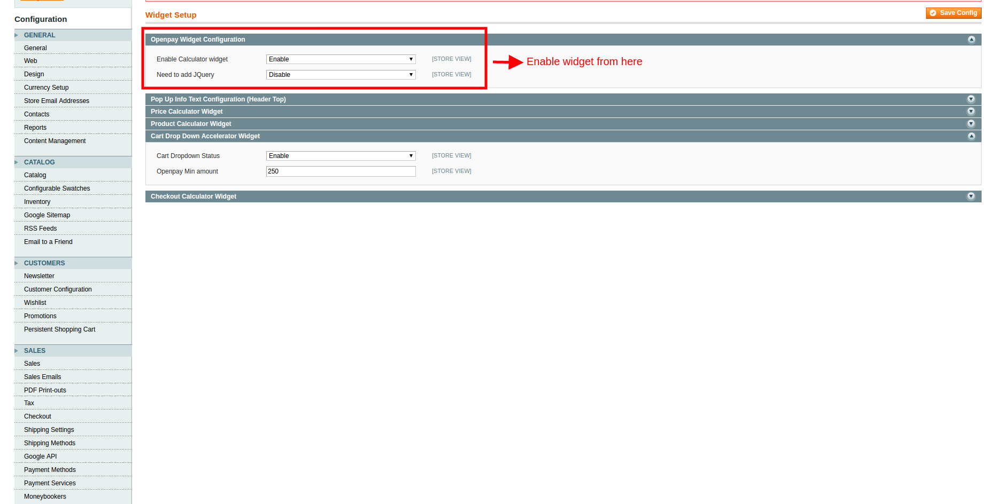

If you don't have a jQuery in your site then only include jQuery from this module

Click on 'Save Config'.

2. Set up 'Checkout Calculator Widget':

Expand 'Checkout Calculator Widget' & fill out the fields as required.

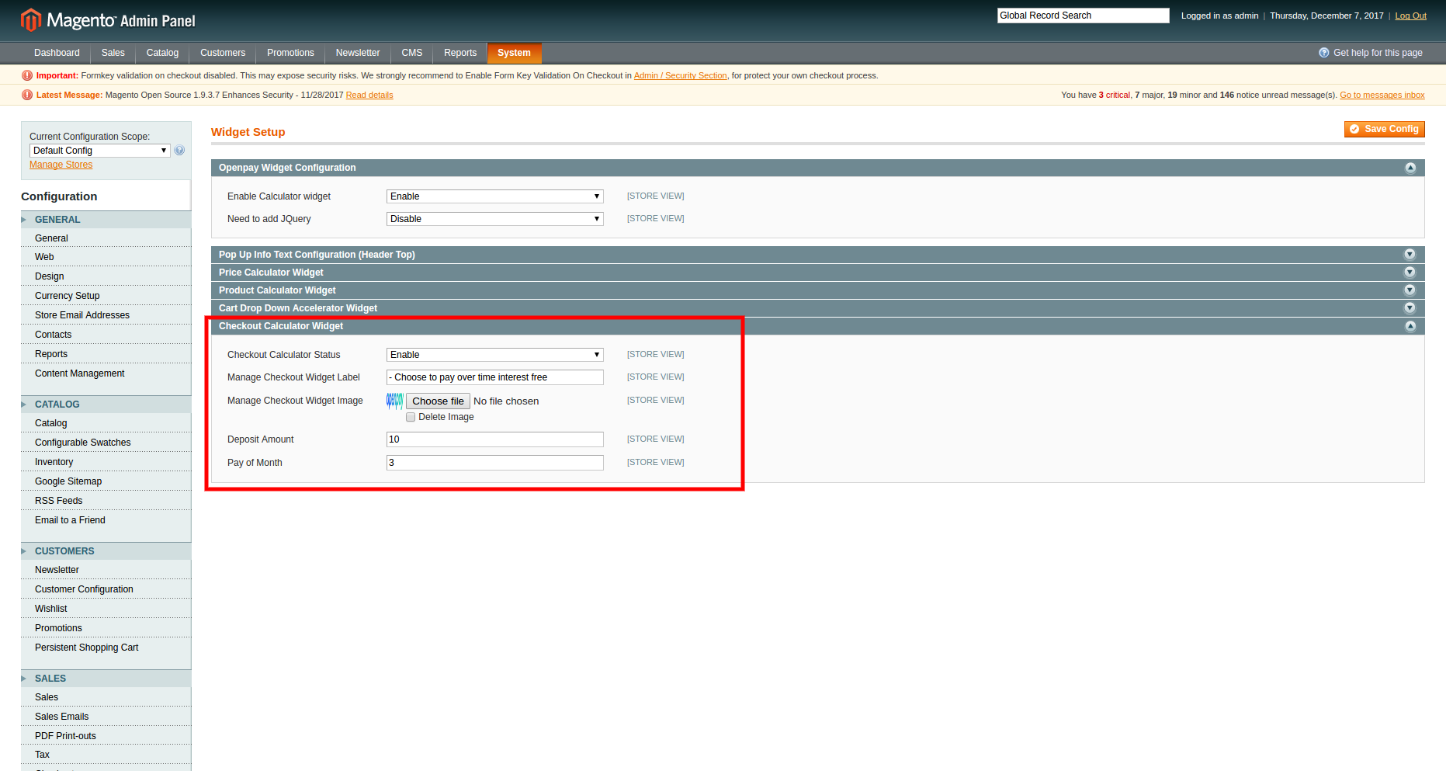

Manage Checkout Widget Label : This text will replace the text of Aopenpay payment method title.
Manage Checkout Widget Image : This image will be added before the widget lable in checkout page. ( use openpay logo here)
Deposit Percentage: Percentage amount
Pay of month: total number of months for full payment
Click on 'Save Config'.

Frontend View :

'Checkout Calculator' widget :

If module is enabled form admin , it will comes in checkout payment method section or in the right panel of checkout page of site.

